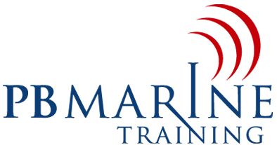
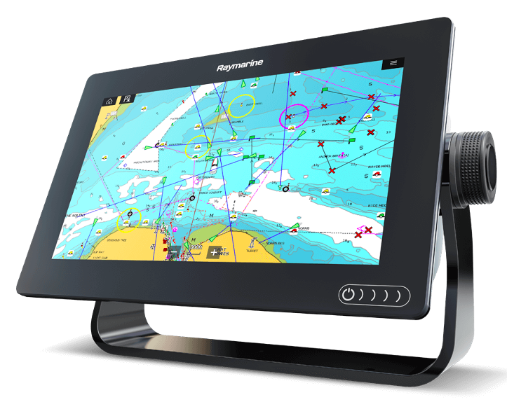
Electronic Navigation
Courses

The majority of skippers use electronic navigation on board yachts these days. Why? It has a whole range of advantages over the traditional navigation, for example:
- The equipment is relatively easy to operate,
- A lot of information is available with the click of a few buttons - and that very fast.
- Updating the chart software has become quite simple.

Nevertheless, electronic navigation on board also has its limitations, which every skipper should be aware of.
This one-day (or two evenings) course serves as an introduction to the subject electronic navigation, and is ideal for skippers and boat-owners who have discovered boating as a new hobby, and who would like to use electronic navigation to guide them safely on the water to their destinations.
The following subjects are presented with a video projector:
- Introduction; The advantages and limitations of electronic navigation
- NMEA/WiFi: The connections between the equipment
- Global Navigation Satellite System (GNSS, GPS, SBAS, etc.)
- The electronic chart, vectors and symbols
- AIS: Typical symbols on the screen; Evaluating the AIS information
- Radar: Collision-avoidance using MARPA, Guard zones and Doppler.
- AutoPilot, Electronic Compasses, Echo sounder, etc.

During the practical part of the course, every participant uses a plotter display unit (Raymarine 12” Axiom display), where he/she can practice the following:
- Evaluating the electronic chart, with all its symbols.
- Evaluating the information regarding vectors, tides and currents, etc.
- Placing a waypoint, setting up a route, Auto-routing.
- AIS overlay: Typical AIS symbols on the screen; Evaluating the AIS information
- Radar: Collision-avoidance using MARPA, Guard zones and Doppler.
- AutoPilot: Heading mode, Waypoint mode, Search modes
- The numerous alarm functions available to protect the boat
- Echo-sounders

Our instructor Peter Boot, spent 5 years in the South-African, British and Canadian merchant navies, followed by 25 years in the Radar industry ashore. For further information please contact:
- Email: info@pbmarinetraining.com
- Mobile: +47 968 61426
- Web: https://pbmarinetraining.com/

